Third-Party Risk Management (TPRM) Roles & Responsibilities Matrix
Organization: Mayekar Technologies Pvt. Ltd.
Document ID: TPRM-002
Version: 1.0
Document Classification: Internal Use
Framework Alignment: ISO/IEC 27001:2022
Effective Date: 01 August 2026

1. Purpose
The purpose of this document is to define the roles, responsibilities, accountability, and decision-making authority of stakeholders involved in the Third-Party Risk Management (TPRM) Program.
Clear ownership shall ensure that third-party security risks are consistently identified, assessed, treated, approved, monitored, and reviewed throughout the third-party lifecycle.

2. Key Stakeholders
The following stakeholders participate in the TPRM lifecycle:
- Executive Management
- GRC / Information Security
- Procurement / Vendor Management
- Business Owner
- IT / System Owner
- Legal / Contract Management
- Privacy / Data Protection
- Finance
- Internal Audit
- Third Party / Supplier

3. Roles and Responsibilities

3.1 Executive Management
Primary Responsibility: Program oversight and significant risk decisions.
Responsibilities:
- Approve the overall TPRM governance framework.
- Provide organizational sponsorship.
- Approve significant or exceptional third-party risks.
- Ensure adequate resources for TPRM activities.
- Review significant third-party risk exposures.
- Support remediation of material risks.

3.2 GRC / Information Security
Primary Responsibility: TPRM framework ownership and security risk management.
Responsibilities:
- Maintain the TPRM framework.
- Define third-party risk assessment methodology.
- Define security assessment requirements.
- Review vendor security documentation.
- Conduct or coordinate security assessments.
- Identify information security risks.
- Maintain the Vendor Risk Register.
- Recommend risk treatment actions.
- Track remediation activities.
- Monitor high and critical third-party risks.
- Coordinate security incident escalation.
- Perform periodic TPRM program reviews.
- Report TPRM metrics to management.

3.3 Procurement / Vendor Management
Primary Responsibility: Vendor lifecycle coordination.
Responsibilities:
- Initiate vendor onboarding.
- Maintain the Vendor Inventory.
- Collect vendor information.
- Coordinate due diligence activities.
- Ensure required assessments are completed before onboarding.
- Coordinate commercial negotiations.
- Maintain vendor and contract records.
- Coordinate vendor renewals.
- Initiate vendor offboarding.

3.4 Business Owner
Primary Responsibility: Business justification and operational ownership.
Responsibilities:
- Define the business requirement for the vendor.
- Identify the services provided.
- Identify business-critical processes affected.
- Identify information and systems involved.
- Participate in vendor classification.
- Review risk assessment results.
- Accept or reject business-related risks within delegated authority.
- Monitor vendor performance.
- Initiate reassessment when business requirements change.

3.5 IT / System Owner
Primary Responsibility: Technical security and access management.
Responsibilities:
- Identify systems accessed by the vendor.
- Validate technical access requirements.
- Apply least-privilege principles.
- Review vendor technical controls.
- Implement appropriate authentication and access controls.
- Monitor privileged or remote access.
- Support technical security assessments.
- Revoke access during vendor termination.

3.6 Legal / Contract Management
Primary Responsibility: Contractual and legal requirements.
Responsibilities:
- Review applicable contracts and agreements.
- Ensure required information security clauses are included.
- Review confidentiality requirements.
- Review data protection obligations.
- Review liability and breach notification provisions.
- Review subcontractor requirements.
- Support contractual enforcement of security obligations.

3.7 Privacy / Data Protection
Primary Responsibility: Privacy and personal-data risk.
Responsibilities:
- Identify privacy implications of vendor relationships.
- Review processing of personal data.
- Assess applicable privacy requirements.
- Review data processing arrangements.
- Validate appropriate privacy and data protection safeguards.
- Support privacy-related incident handling.

3.8 Finance
Primary Responsibility: Financial and payment-related oversight.
Responsibilities:
- Support vendor financial due diligence where applicable.
- Validate payment and financial requirements.
- Support identification of financially critical suppliers.
- Participate in risk decisions involving material financial exposure.

3.9 Internal Audit
Primary Responsibility: Independent assurance.
Responsibilities:
- Assess the effectiveness of the TPRM framework independently.
- Review compliance with established TPRM procedures.
- Evaluate adequacy of controls.
- Identify audit findings where applicable.
- Track corrective actions.
- Report significant control weaknesses through the appropriate audit process.
Internal Audit shall maintain appropriate independence from operational ownership of the TPRM process.

3.10 Third Party / Supplier
Primary Responsibility: Compliance with agreed security requirements.
Responsibilities:
- Provide accurate organizational and security information.
- Complete required security questionnaires.
- Provide requested security evidence.
- Comply with contractual security requirements.
- Maintain agreed security controls.
- Notify the organization of applicable security incidents.
- Cooperate with security reviews and reassessments.
- Manage subcontractors in accordance with contractual requirements.
- Support secure offboarding.

4. RACI Matrix
R = Responsible
A = Accountable
C = Consulted
I = Informed
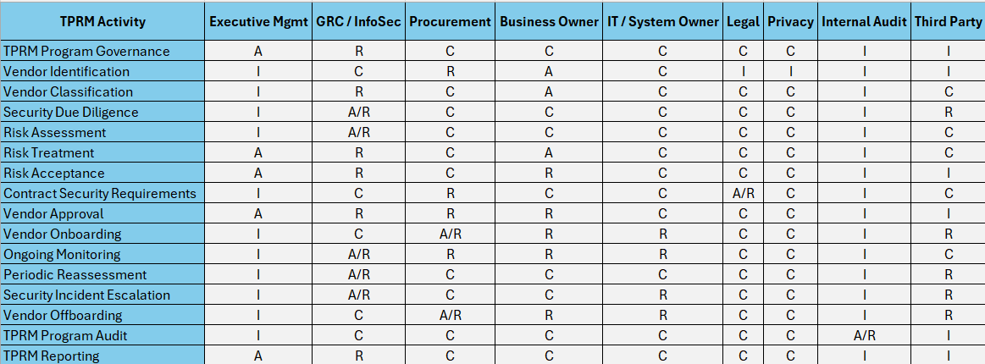

5. Decision-Making Authority
Third-party decisions shall be made according to the organization's defined risk acceptance authority.
Low Risk
Routine approval may be performed by the designated Business Owner and applicable operational stakeholders.
Medium Risk
Approval shall require appropriate Business Owner and GRC / Information Security review.
High Risk
Approval shall require formal GRC / Information Security review and appropriate management authorization.
Critical Risk
Critical third-party relationships shall require senior management approval and documented risk acceptance where residual risk remains above the organization's defined tolerance.

6. Segregation of Duties
Where practical, critical TPRM activities shall maintain appropriate segregation of duties.
The individual requesting a vendor service should not independently:
- Perform the complete security assessment,
- Approve their own identified risk,
- Approve contractual security exceptions,
- And independently authorize the final high-risk relationship.
Appropriate independent review shall be applied to significant third-party risks.

7. Escalation
Third-party risks shall be escalated when:
- A critical security control is absent.
- A high or critical residual risk remains untreated.
- A vendor experiences a significant security incident.
- Contractual security requirements are violated.
- Required remediation becomes overdue.
- A material change occurs in the vendor's service or security posture.
- A third-party becomes critical to a key business process.
- A significant regulatory or contractual obligation may be affected.

8. Review and Maintenance
This document shall be reviewed:
- At least annually;
- When the TPRM operating model changes;
- When organizational responsibilities change;
- Following significant security incidents;
- Following material changes to regulatory or contractual requirements.
Changes shall be documented and approved according to the organization's document control requirements.

Prepared By: Omkar Abhay Mayekar
Document Owner: Information Security / GRC
Review Frequency: At least annually or upon significant change
Version: 1.0
Status: Draft for Review

